Liam Chen's Storyboard
Storyboard Overview

Morning Routine  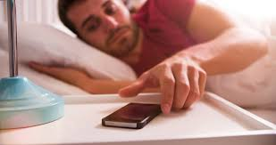  Liam wakes up and checks notifications right away, scrolling through social media before getting out of bed. | Distraction at School  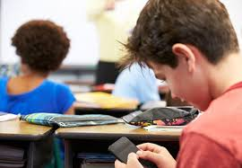  During class, he gets distracted by messages and TikToks, losing focus.
Using the App  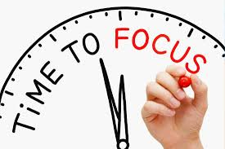  The app blocks social media during class and rewards focus time. | Outcome  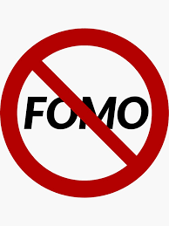  Liam feels more productive and calm, without FOMO.
Realization  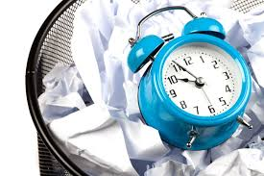  He realizes he’s wasting time and missing deadlines. | Discovery    Liam finds an app called 'DoomNoMore' that helps him focus.

Jasmine Ortiz's Storyboard

Morning Rush    Jasmine wakes up and checks her client accounts immediately. | Constant Notifications  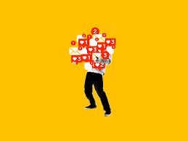  Her phone buzzes with analytics and messages all day.
Overwhelmed    She feels burnout from being online constantly. | Discovery  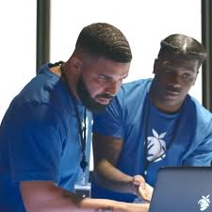  She sees a post about 'DoomNoMore' and downloads it.
Using the App  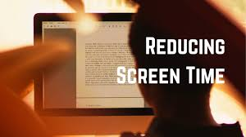  She sets work and personal screen time limits. | Outcome    Jasmine feels balanced, spending evenings offline with her fiancé.

Noah Rivera's Storyboard
Storyboard Overview

Morning Scroll    Noah starts his day watching funny TikToks before school. | Lost Time  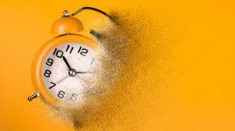  He loses hours scrolling through videos after homework.
Concern    His parents worry about screen time. | Discovery  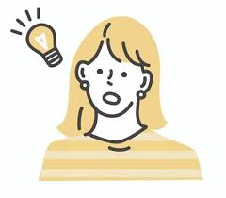  He finds 'DoomNoMore' through a school challenge.
Using the App  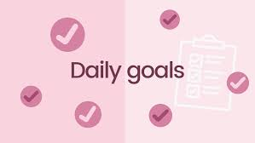  The app gives him daily screen goals and fun challenges. | Outcome    Noah spends more time with friends and feels proud of his progress.

Priya Patel's Storyboard
Storyboard Overview

Work Overload    Priya checks work emails on her phone even during dinner. | Distraction Cycle  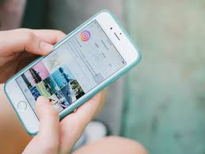  She scrolls through Instagram while taking breaks.
Guilt  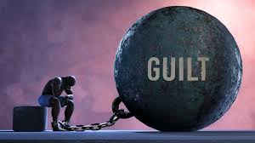  She feels disconnected from her family. | Discovery    She reads about 'DoomNoMore' in a wellness blog.
Using the App  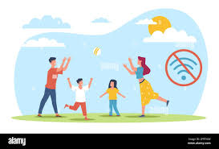  She schedules offline hours for family time. | Outcome  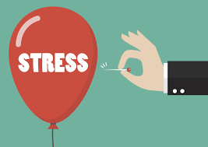  Priya feels reconnected, less stressed, and more present.

